**Project Design Phase-II**

**Data Flow Diagram & User Stories**

|  |  |
| --- | --- |
| Date | 26 June 2025 |
| Team ID | LTVIP2025TMID35580 |
| Project Name | Citizen AI – Intelligent Citizen Engagement Platform |
| Maximum Marks | 4 Marks |

**Data Flow Outline**

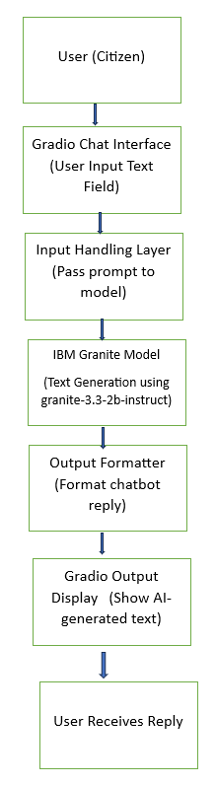

**User Stories**

Use the below template to list all the user stories for the product.

| **User Type** | **Functional Requirement (Epic)** | **User Story Number** | **User Story / Task** | **Acceptance criteria** | **Priority** | **Release** |
| --- | --- | --- | --- | --- | --- | --- |
| Citizen (Web User) | Real-Time Chat Assistant | USN-1 | As a citizen, I can type my question into a chat interface | I see a text box where I can type a message | High | Sprint-1 |
| Citizen (Web User) | Real-Time Chat Assistant | USN-2 | As a citizen, I receive a response from the AI model after submitting my question | I receive an AI-generated answer on the screen | High | Sprint-1 |
| Citizen (Web User) | Public Service Info Access | USN-3 | As a citizen, I can ask service-related questions like "How to apply for driving license" | The bot gives clear, context-aware info about government services | High | Sprint-2 |
| Admin/Developer | Model Setup & Integration | USN-4 | As a developer, I can download and run the IBM Granite model locally | The model loads and generates outputs using local resources | Medium | Sprint-1 |
| Admin/Developer | Chat UI Deployment | USN-5 | As a developer, I can host and share the chatbot via a public Gradio link | Others can access the chatbot using a generated share link | Medium | Sprint-2 |